Progress Report  Author:  Qualification:  Institution: | Dr Wayne Ng B.Sc MBBS  Ph.D Neuro-oncology  Department of Surgery, Royal Melbourne Hospital, Parkville, VIC  Department of Surgery, University of Melbourne, Parkville, VIC

Title: Utilisation of glioma stem cells to investigate novel therapies for glioblastoma multiforme

Glioblastoma multiforme (GBM) is the most common malignant brain cancer and has a very poor survival (7-15 months) despite current best treatment (surgery, chemotherapy (temozolomide) and irradiation). Glioma stem cells (GSC) are a new concept in glioma research described as representing the ‘life source’ of GBM by providing the tumour with an unlimited capacity to regrow. Preliminary studies in the Royal Melbourne Hospital Department of Surgery Brain Tumour Laboratory have established a number of these human tumour-derived GSC lines. These cells have been confirmed to possess the quality of self- renewal/immortality making them an ideal platform to further investigate this form of brain cancer. In addition, the majority of these cells contain mutations in their survival pathways, including the PI3K/Akt signalling pathway. The PI3K pathway forms the ‘final common pathway’ of many of these ‘survival events’, and thus may represent a more universal and rational therapeutic target in GBM. Furthermore, PI3K signalling may also be involved in glioma cell invasion – another reason for treatment resistance. Therefore, PI3K inhibitors are of intense interest for the treatment of glioma. We have demonstrated that current standard chemotherapy (temozolomide) has no appreciable cytotoxic effect on GSC but that in vitro treatment of GSC with a selective PI3K inhibitor (BKM120) can induce moderate levels of cytotoxicity (up to 50%).

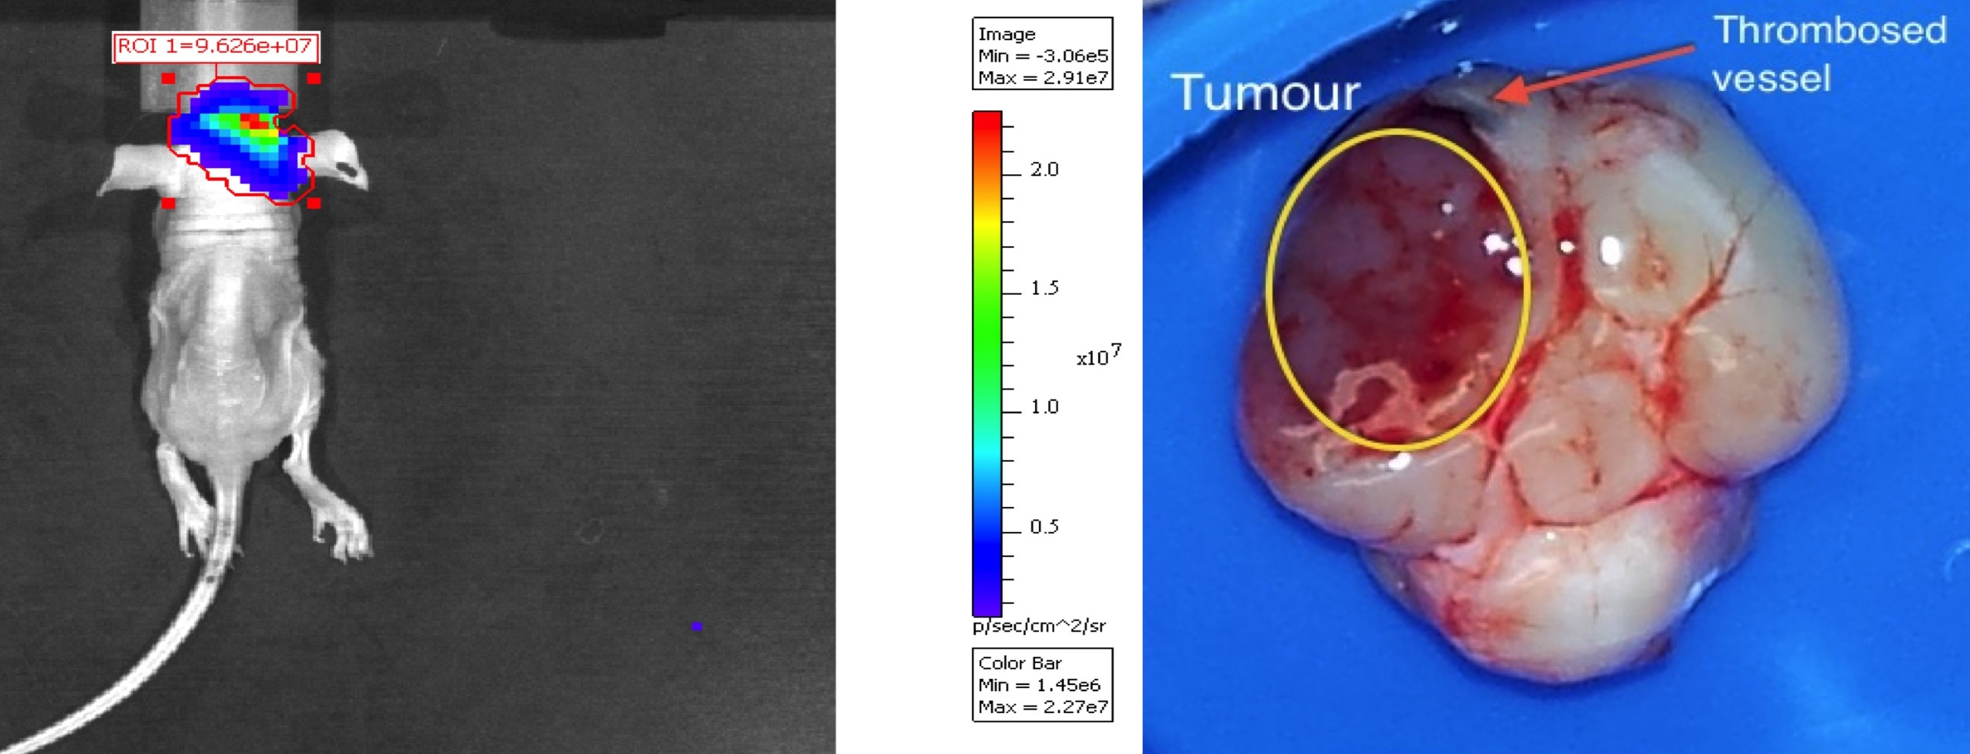

Some of our GSC lines have been incorporated into a 'glowing' GSC mouse model that allows real-time assessments of tumour growth and response to treatments. This is achieved using in vivo bioluminescence (CaliperTM IVIS system). These intracerebral GSC brain tumour models have the potential to more closely mimic human GBM when compared to tumours injected under the skin. We will be using this in vivo intracerebral brain tumour model to study the effect of BKM120. A Phase I clinical trial investigating the effect of BKM120 is already underway and patients at RMH have been enrolled. The in vivo results will be reported in conjunction with the human clinical trial, to help establish translational validity of the GSC xenograft model, and therefore establish if it has a role as a preclinical drug screening model.

