Progress Report

Author: Dr. Xiangjian Zheng
Qualification: Ph.D
Institution: Centenary Institute
Date: 28/10/2017

Title of Project: Towards a therapeutic for Cerebral cavernous malformation (CCM): targeting Adamts

Summary: (approximately 1,000 words)
In the proposed research, we planned to test: 1) whether inhibition of Adamts with AGG-523 and Compound13b can block lesion formation, 2) whether inhibition of Adamts can reverse the abnormal Rho signalling caused by CCM mutation.
During this past year after we received the gift, we have used both genetic and pharmacological methods to investigate the CCM-MEKK3-KLF-Adamts pathway in CCM pathogenesis. Our previous work has established that MEKK3 activation is a cause factor for disease formation. Its activation lead to increased activation of Adamts. When searching for the upstream activator of MEKK3-Adamts axis, we identified gut microbiota promotes CCM lesion formation via LPS-TLR4 signaling. Depletion of microbiota or block of TLR4 signaling decreases both Adamts expression and Rho signalling activation, and prevents CCM lesion formation (Fig. 1). This body of work has been published in Nature this year.
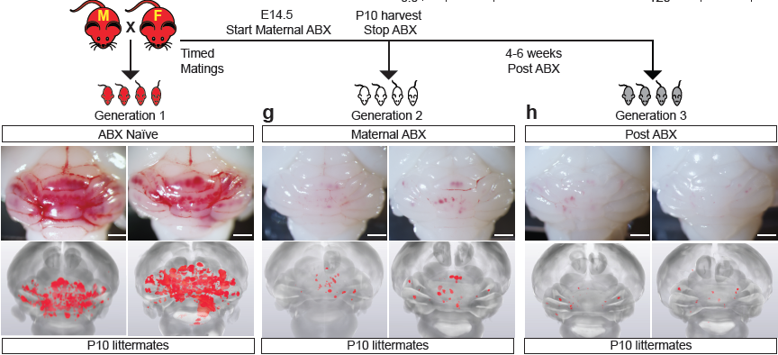

Fig1. Antibiotic treatment prevents CCM lesion formation in mouse model (Adopted from Tang et al, Nature 545: 305-310)

Meanwhile we have continued the work to directly intervene Adamts activity. We concluded that genetic deletion of Adamts5 gene potently inhibit CCM lesion formation in CCM2 mutant mice, but only have mild effect in CCM1 mutant mice, suggest CCM1 and CCM2 gene may differentially regulate Adamts genes. We have also used compound 13, an inhibitor of both Adamts4 and 5 to treat CCM mutant mice. We have found that this compound can have mild activity in inhibiting CCM lesion formation, but severely blocked joint remodelling in neonatal mice. Therefore we did not continue on experiments using Adamts inhibitor. Instead, we screened the kinase inhibitor library to search inhibitor of upstream kinase cascade to control Adamts expression. We identified two compounds potently inhibit KLF and Adamts gene expression. One of the compound, a currently FDA approved drug, can reduce CCM lesion burden to ~15% in mice (Fig 2). In summary we have find a compound, which is able to effectively inhibit KLF2/Adamts expression and prevent CCM lesion formation.
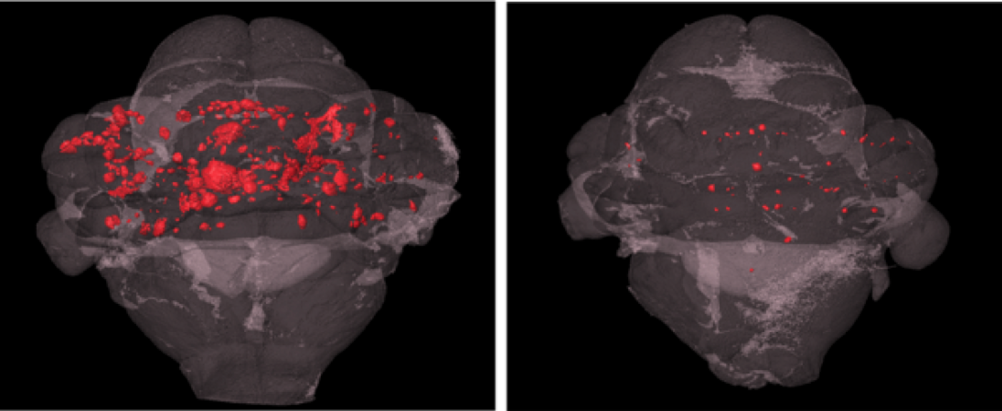
Fig2. A new compound inhibits CCM lesion formation in mouse model.

Hypothesis vs Findings
Hypothesis: Targeting Adamts will effectively treat CCM disease
Finding:
1. Depleting gut microbiota prevent CCM lesion formation.
2. A compound inhibit KLF/Adamts expression can effective block CCM
lesion formation.

Unanswered Questions:
Does Adamts activity directly alter Rho activity, which is tightly associated with CCM lesions?

What these research outcomes mean
- Provided pre-clinical bases for test antibiotics or anti-inflammatory therapy may in CCM patient.
- A FDA approved new drug for other diseases can be considered for CCM treatment.

